**Library Management System Project**

**1. Problem Statement**

Manual book management in libraries leads to errors and inefficiencies, making it difficult to track borrowed, rented, or ordered books.

**2. Requirements**

**Hardware:**

* Computer or laptop with basic specifications.

**Software:**

* Python
* JSON file for storing data.

**Functional Requirements:**

* Add, view, borrow, return, rent, and order books.
* Data persistence using JSON files.

**3. Proposed Solution**

A Python-based system that automates book management tasks like borrowing, returning, renting, and ordering. It uses a JSON file to store book details and tracks borrowed/rented books and orders.

**4. Features**

1. **Add Books:** Add new books or update quantities.
2. **View Books:** List all books with availability.
3. **Borrow Books:** Borrow books if available.
4. **Return Books:** Return borrowed books.
5. **Rent Books:** Rent books for a fixed period (e.g., 14 days).
6. **Order Books:** Order books if all copies are borrowed.
7. **Data Persistence:** Saves data to a JSON file.

**5. Future Scope**

1. **Database Integration:** Use MySQL or SQLite for scalability.
2. **User Authentication:** Add login systems for users and admins.
3. **Online System:** Web or mobile app for remote access.
4. **Overdue Notifications:** Automatically notify users of overdue books.

**6. Conclusion**

The system simplifies library management tasks and reduces manual errors. Future upgrades like a web version and better user interaction will make it more efficient for users and staff.

7.Code

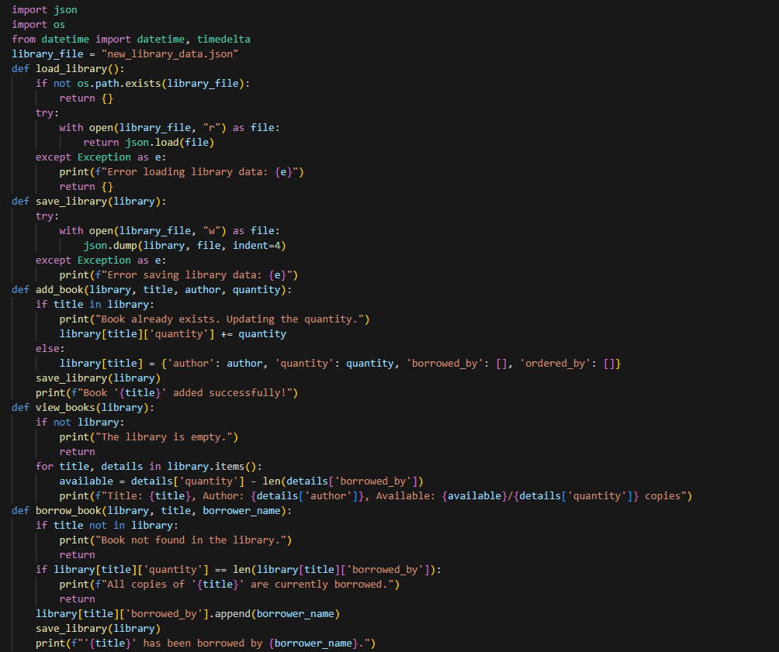

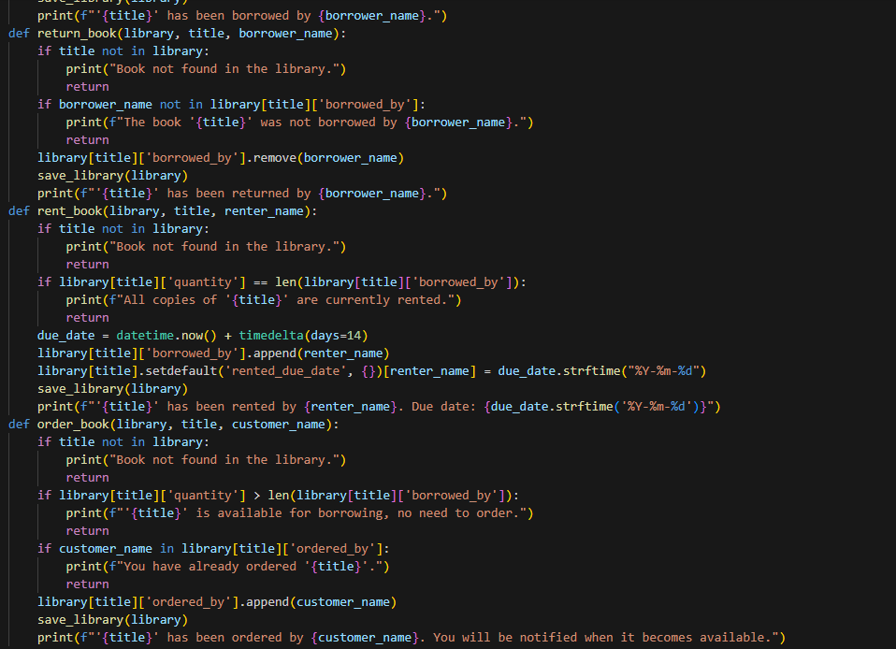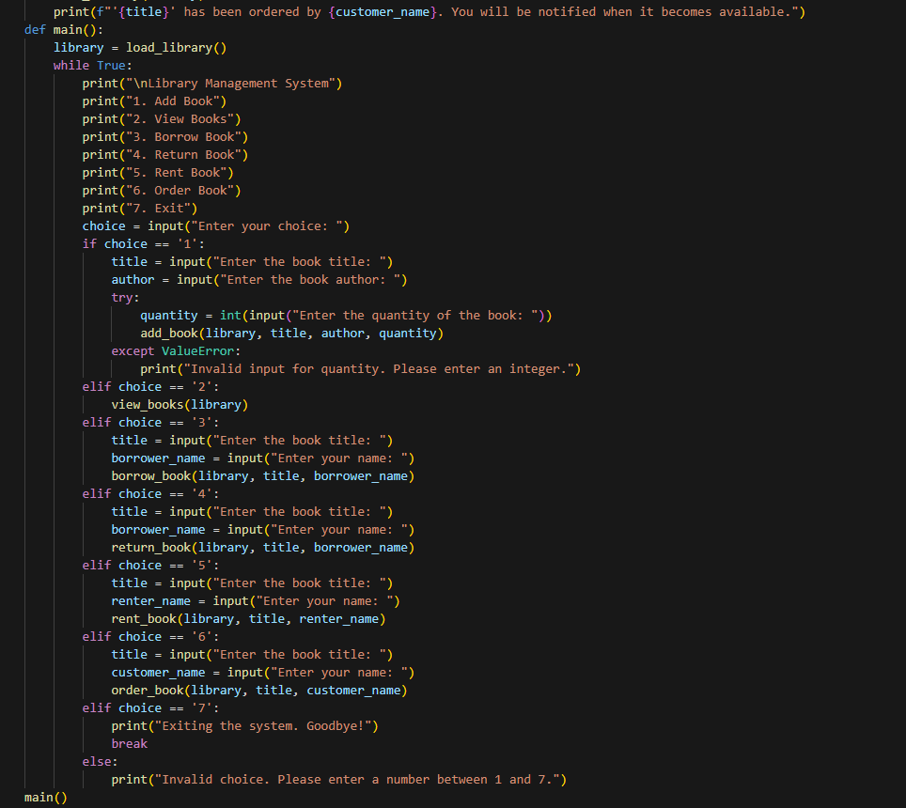

8.Output

